**Hbase : Assignment 9.3**

**Q. Explain the below concept with an example in brief.**

**1) NoSql Databases :-**

NoSQL means Not Only SQL, implying that when designing a software solution or product, there are more than one storage mechanism that could be used based on the needs. NoSQL was a hashtag (#nosql) choosen for a meetup to discuss these new databases. The most important result of the rise of NoSQL is Polyglot Persistence.  NoSQL encompasses a wide variety of different database technologies that were developed in response to the demands presented in building modern applications:

* Developers are working with applications that create massive volumes of new, rapidly changing data types - structured, semi-structured, unstructured and polymorphic data.
* Long gone is the twelve-to-eighteen month waterfall development cycle. Now small teams work in agile sprints, iterating quickly and pushing code every week or two, some even multiple times every day.
* Applications that once served a finite audience are now delivered as services that must be always-on, accessible from many different devices and scaled globally to millions of users.
* Organizations are now turning to scale-out architectures using open source software, commodity servers and cloud computing instead of large monolithic servers and storage infrastructure.

Relational databases were not designed to cope with the scale and agility challenges that face modern applications, nor were they built to take advantage of the commodity storage and processing power available today.

**2) Type of No SQL data bases :-**

* **Document databases** pair each key with a complex data structure known as a document. Documents can contain many different key-value pairs, or key-array pairs, or even nested documents.
* **Graph stores** are used to store information about networks of data, such as social connections. Graph stores include Neo4J and Giraph.
* **Key-value stores** are the simplest NoSQL databases. Every single item in the database is stored as an attribute name (or 'key'), together with its value. Examples of key-value stores are Riak and Berkeley DB. Some key-value stores, such as Redis, allow each value to have a type, such as 'integer', which adds functionality.
* **Wide-column stores** such as Cassandra and HBase are optimized for queries over large datasets, and store columns of data together, instead of rows.

**3) CAP Theorem :-**

In a distributed system, managing consistency(C), availability(A) and partition toleration(P) is important, Eric Brewer put forth the **CAP theorem** which states that in any distributed system we can choose only two of consistency, availability or partition tolerance. Many NoSQL databases try to provide options where the developer has choices where they can tune the database as per their needs. For example if you consider [Riak](http://basho.com/riak) a distributed key-value database. There are essentially three variables r, w, n where,

* r=number of nodes that should respond to a read request before its considered successful.
* w=number of nodes that should respond to a write request before its considered successful.
* n=number of nodes where the data is replicated aka replication factor.

In a Riak cluster with 5 nodes, we can tweak the r,w,n values to make the system very consistent by setting r=5 and w=5 but now we have made the cluster susceptible to network partitions since any write will not be considered successful when any node is not responding. We can make the same cluster highly available for writes or reads by setting r=1 and w=1  but now consistency can be compromised since some nodes may not have the latest copy of the data. The CAP theorem states that if you get a network partition, you have to trade off availability of data versus consistency of data. Durability can also be traded off against latency, particularly if you want to survive failures with replicated data.

NoSQL databases provide developers lot of options to choose from and fine tune the system to their specific requirements.  Understanding the requirements of how the data is going to be consumed by the system, questions such as is it read heavy vs write heavy, is there a need to query data with random query parameters, will the system be able handle inconsistent data.

Understanding these requirements becomes much more important, for long we have been used to the default of  RDBMS which comes with a standard set of features no matter which product is chosen and there is no possibility of choosing some features over other. The availability of choice in NoSQL databases, is both good and bad at the same time. Good because now we have choice to design the system according to the requirements. Bad because now you have a choice and we have to make a good choice based on requirements and there is a chance where the same database product may be used properly or not used properly.

An example of feature provided by default in RDBMS is transactions, our development methods are so used to this feature that we have stopped thinking about what would happen when the database does not provide transactions. Most NoSQL databases do not provide transaction support by default, which means the developers have to think how to implement transactions, does every write have to have the safety of transactions or can the write be segregated into “critical that they succeed” and “its okay if I lose this write” categories. Sometimes deploying external transaction managers like [ZooKeeper](https://zookeeper.apache.org/) can also be a possibility.

**4) Hbase Architecture :-**

HBase provides low-latency random reads and writes on top of HDFS. In HBase, tables are dynamically distributed by the system whenever they become too large to handle (Auto Sharding). The simplest and foundational unit of horizontal scalability in HBase is a Region. A continuous, sorted set of rows that are stored together is referred to as a region (subset of table data).  HBase architecture has a single HBase master node (HMaster) and several slaves i.e. region servers. Each region server (slave) serves a set of regions, and a region can be served only by a single region server. Whenever a client sends a write request, HMaster receives the request and forwards it to the corresponding region server. HBase can be run in a multiple master setup, wherein there is only single active master at a time. HBase tables are partitioned into multiple regions with every region storing multiple table’s rows.

**Components of Apache HBase Architecture :-**

HBase architecture has 3 important components- HMaster, Region Server and ZooKeeper.

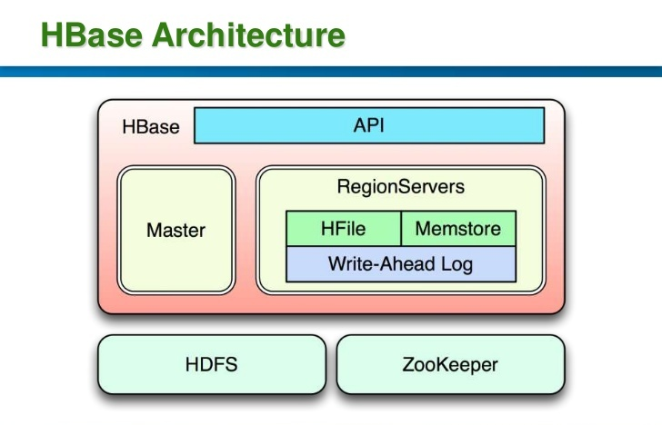

1. **HMaster**

HBase HMaster is a lightweight process that assigns regions to region servers in the Hadoop cluster for load balancing. Responsibilities of HMaster –

* Manages and Monitors the Hadoop Cluster
* Performs Administration (Interface for creating, updating and deleting tables.)
* Controlling the failover
* DDL operations are handled by the HMaster
* Whenever a client wants to change the schema and change any of the metadata operations, HMaster is responsible for all these operations.

1. **Region Server**

These are the worker nodes which handle read, write, update, and delete requests from clients. Region Server process, runs on every node in the hadoop cluster. Region Server runs on HDFS DataNode and consists of the following components –

* Block Cache – This is the read cache. Most frequently read data is stored in the read cache and whenever the block cache is full, recently used data is evicted.
* MemStore- This is the write cache and stores new data that is not yet written to the disk. Every column family in a region has a MemStore.
* Write Ahead Log (WAL) is a file that stores new data that is not persisted to permanent storage.
* HFile is the actual storage file that stores the rows as sorted key values on a disk.

1. **Zookeeper**

HBase uses ZooKeeper as a distributed coordination service for region assignments and to recover any region server crashes by loading them onto other region servers that are functioning. ZooKeeper is a centralized monitoring server that maintains configuration information and provides distributed synchronization. Whenever a client wants to communicate with regions, they have to approach Zookeeper first. HMaster and Region servers are registered with ZooKeeper service, client needs to access ZooKeeper quorum in order to connect with region servers and HMaster. In case of node failure within an HBase cluster, ZKquoram will trigger error messages and start repairing failed nodes.

ZooKeeper service keeps track of all the region servers that are there in an HBase cluster- tracking information about how many region servers are there and which region servers are holding which DataNode. HMaster contacts ZooKeeper to get the details of region servers. Various services that Zookeeper provides include –

* Establishing client communication with region servers.
* Tracking server failure and network partitions.
* Maintain Configuration Information
* Provides ephemeral nodes, which represent different region servers.

Understanding the fundamental of HBase architecture is easy but running HBase on top of HDFS in production is challenging when it comes to monitoring compactions, row key designs manual splitting, etc. If you would like to learn how to design a proper schema, derive query patterns and achieve high throughput with low latency then enrol now for comprehensive hands-on [Hadoop Training](https://www.dezyre.com/Hadoop-Training-online/19" \o "Online Hadoop Training" \t "_blank).

**5) Hbase v/s RDBMS :-**

HBASE and other column-oriented DATABASE are often compared to more traditional and popular relational database or RDBMS.

|  |  |
| --- | --- |
| **HBase** | **RDBMS** |
| 1. Column-oriented | 1. Row-oriented(mostly) |
| 2. Flexible schema, add columns on the Fly | 2. Fixed schema |
| 3. Good with sparse tables. | 3. Not optimized for sparse tables. |
| 4. No query language | 4. SQL |
| 5. Wide tables | 5. Narrow tables |
| 6. Joins using MR – not optimized | 6. optimized for Joins(small, fast ones) |
| 7. Tight – Integration with MR | 7. Not really |
| 8. De-normalize your data. | 8. Normalize as you can |
| 9. Horizontal scalability-just add hard war. | 9. Hard to share and scale. |
| 10. Consistent | 10. Consistent |
| 11. No transactions. | 11. transactional |
| 12. Good for semi-structured data as well as structured data. | 12. Good for structured data. |